GraphPad t test calculator results for TROVE and TROV (using latency)
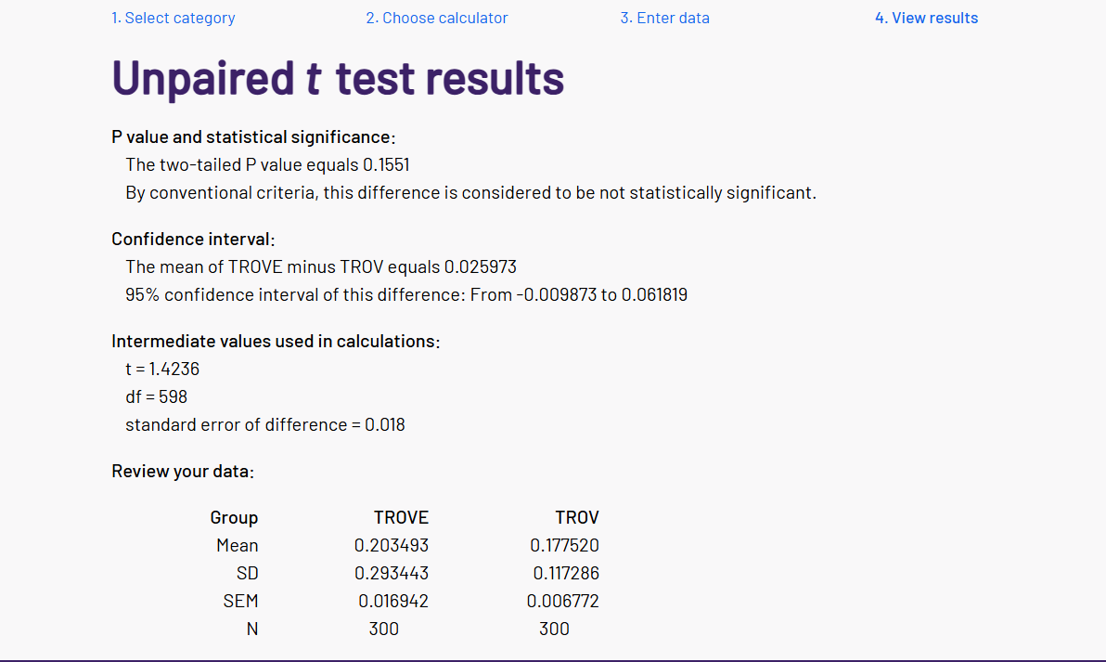

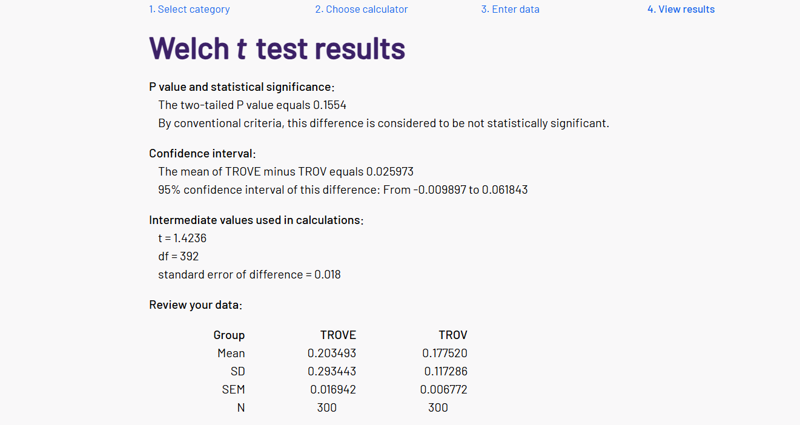
Analysis: The difference is not statistically significant. TROVE had a slightly higher mean latency (0.203 vs 0.178 seconds), and notably a much higher standard deviation (0.293 vs 0.117), meaning TROVE's response times were more inconsistent.
TROVE emission: 0.002591831359216838 kgCO2
TROVE accuracy: 47%
TROV emission: 0.002262176110251541 kgCO2
TROV accuracy: 47%
GraphPad t test calculator results for TROVE and TOVE (using latency)
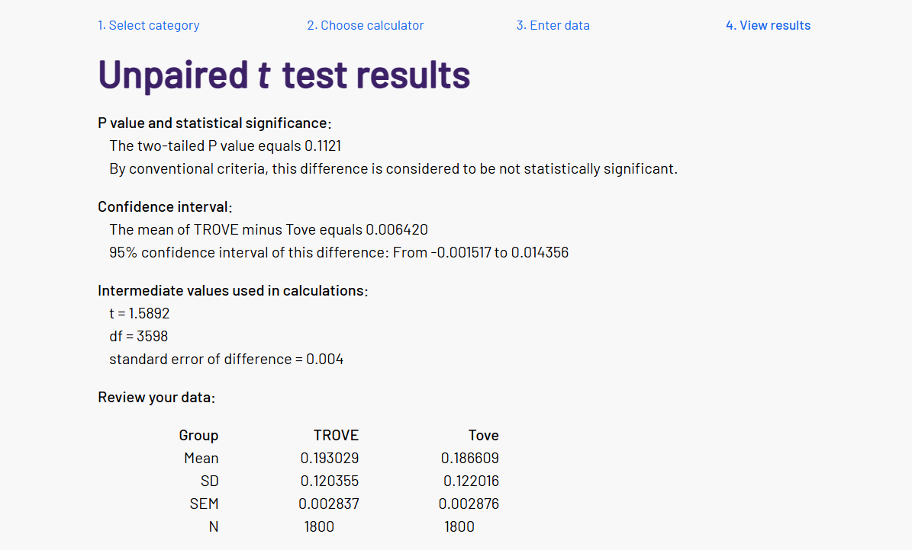
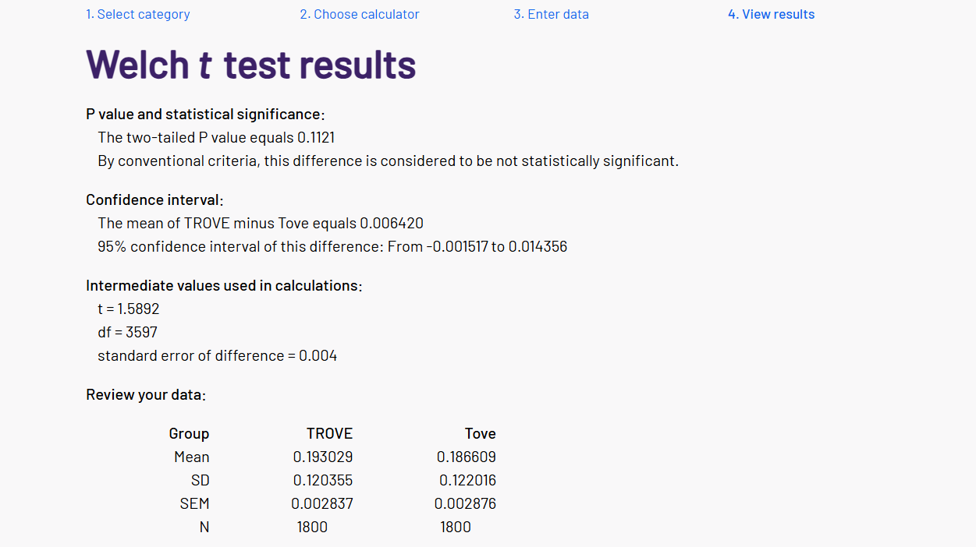
Analysis: Again, not statistically significant. The mean difference here is much smaller (0.193 vs 0.187) and the standard deviations are almost identical (~0.120 vs 0.122). The confidence interval is also very tight (-0.0015 to 0.014).
TROVE emissions (used 600 dataset samples): 0.014856496236759144 kgCO2
TROVE accuracy: 42.67%
TOVE emissions: 0.01459233290788934 kgCO2
TOVE accuracy: 44.83%

